**Staunton Harold Sailability Trust Venue Guide**

This guide has been created by the RYA Midlands Team in partnership with Staunton Harold ST to give an overview of the venue facilities. It may be useful for you to have further information or to discuss the venue with someone before you attend your RYA Midlands course/event here. Details are provided below to help you do this.

**Location and contact information:**

Staunton Harold Reservoir, Calke Road, Melbourne. Derbyshire DE73 8DL

Follow Sat Nav for Staunton Harold Visitor Centre

What3words: ///confronts.oils.clicher

Phone: 07729 491140

Email: sailability@shst.org.uk

**Public transport** is available to the nearest road to the club entrance via the Number 2 bus from Derby to Melbourne.

This drops on Robinsons Hill, approximately a 10min walk from the club entrance.

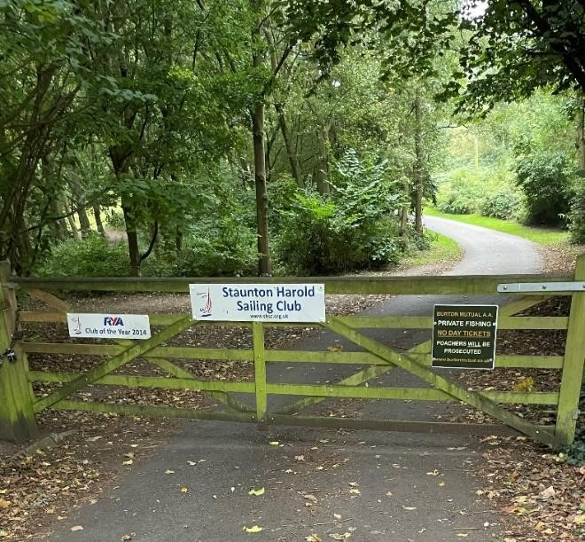

*Figure*

*1*

*:*

*The club site entrance through a wooden gate*

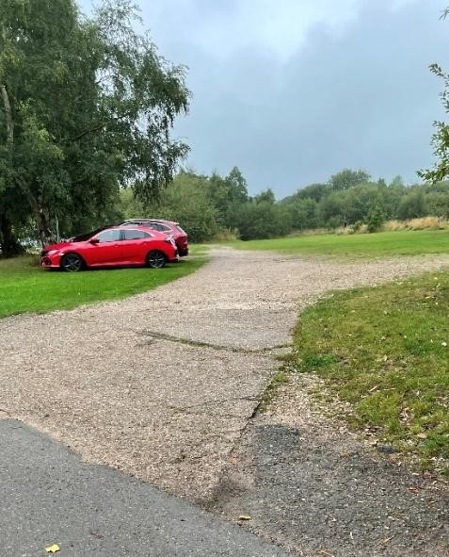

*Figure*

*2*

*:*

*The car park is grass with a gravel pathway*

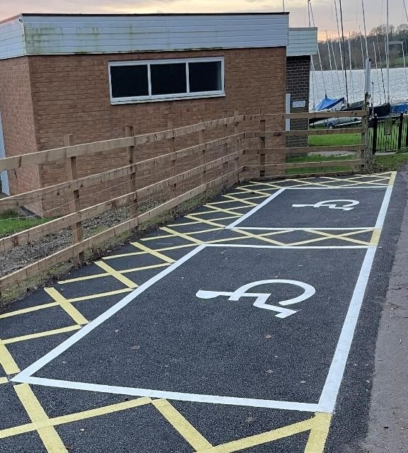

**Entry to the site** is via a wooden gate, which needs opening on entry and closing behind you. The club compound is then accessed via a private road, with the car park entrance on the right.

The main car park has a gravel road with large, grassed areas for parking. There are two clearly marked out parking spaces close to the club building for disabled parking.

**External routes around the site** are flat block paving.

**The main entrance** is on the lake facing side of the building, accessed through a small gate, following a path around the right side of the building.

*Figure 3: Parking spaces for blue badge holders*

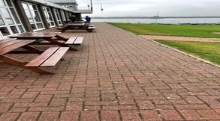

*Figure*

*4*

*:*

*The path to the clubhouse entrance, with the*

*main*

*entrance on the left*

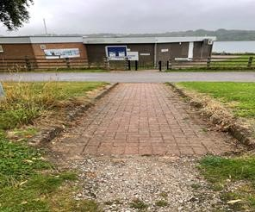

*Figure*

*5*

*:*

*The path from the car park to the club house*

**Inside the clubhouse** the doors and corridors are wide enough for wheelchairs to access. The main club area is spacious with clear routes to access tables and the galley area. Service at the galley is across a low desk.

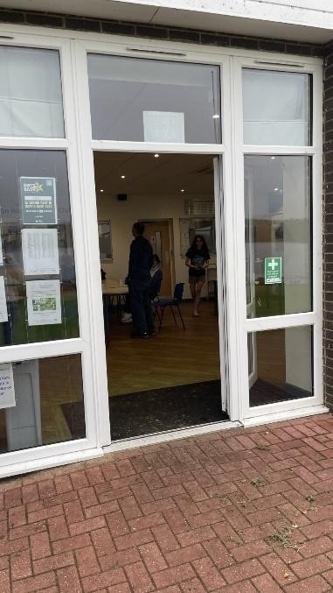

*Figure*

*6*

*:*

*Main Club Entrance*

*Door*

**Toilet and changing areas** are available. Each changing room has an area which can be curtained off for privacy. There is a separate spacious accessible changing room with toilet and shower.

**Accessing the water** is across the grassed dinghy park area, which gently slopes towards the water. There are eight concrete slipways.

**There are two pontoons.** The first is primarily used for powerboats and has a metal mesh access ramp which may not suitable for wheelchairs. The second pontoon is flat with ramp access and a floating stable structure. The edges of the pontoons have no visual markers.

**Boats suitable for wheelchair users and hoists with operators** may be available with prior arrangement.

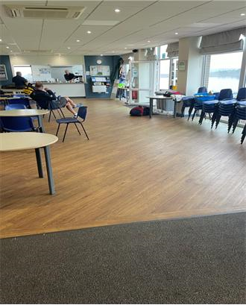**If alerted about a fire or emergency by a club member** exit from the building through fire exits. If a personal evacuation plan is required please discuss requirements with your course organiser beforehand.

**Further information:**

The club, course organiser and the RYA regional team are happy to discuss any of the above information with you and answer any questions you may have. Please get in touch with the club on the contact details above, or your course organiser, who will be in touch before your course. If you have further questions, please feel free to get in touch with the Regional Manager by emailing ben.hodgson@rya.org.uk.